|  |
| --- |
| Mohamed Ashraf 24P0024  Ahmed Hesham 24P0029  Faris Mohamed 24P0233 |
|  |

|  |
| --- |
| Ain Shams University, Faculty of Engineering |
| Event Management System |
| To: Eng/ Mazen |

Table of Contents

**Class Diagram** 1

**Detailed Description** 2

• **Database (abstract)** 3

**Data Fields:** 3

**Functions:** 3

• **DataType (Enum)** 4

**Data Fields:** 4

**Functions:** 4

• **User (Abstract)** 4

**Data Fields:** 4

**Functions:** 4

• **Gender (Enum)** 4

**Data Fields:** 4

**Functions:** 4

• **Admin (extends User)** 4

**Data Fields:** 4

**Functions:** 5

• **Organizer (extends User)** 5

**Data Fields:** 5

**Functions:** 5

• **Attendee (extends User)** 6

**Data Fields:** 6

**Functions:** 6

• **Room** 6

**Data Fields:** 6

**Functions:** 6

• **Event** 7

**Data Fields:** 7

**Functions:** 7

• **Status (Enum)** 8

• **Category** 8

**Data Fields:** 8

**Functions:** 8

• **Wallet** 8

**Data Fields:** 8

**Functions:** 8

• **TimeRange** 8

**Data Fields:** 8

**Functions:** 9

• **Hours** 9

**Data Fields:** 9

**Functions:** 9

• **Day (Enum)** 10

**Data Fields:** 10

**Functions:** 10

• **MyDate** 10

**Data Fields:** 10

**Functions:** 10

**Demo** 11

**GitHub Link** 25

# **Class Diagram**

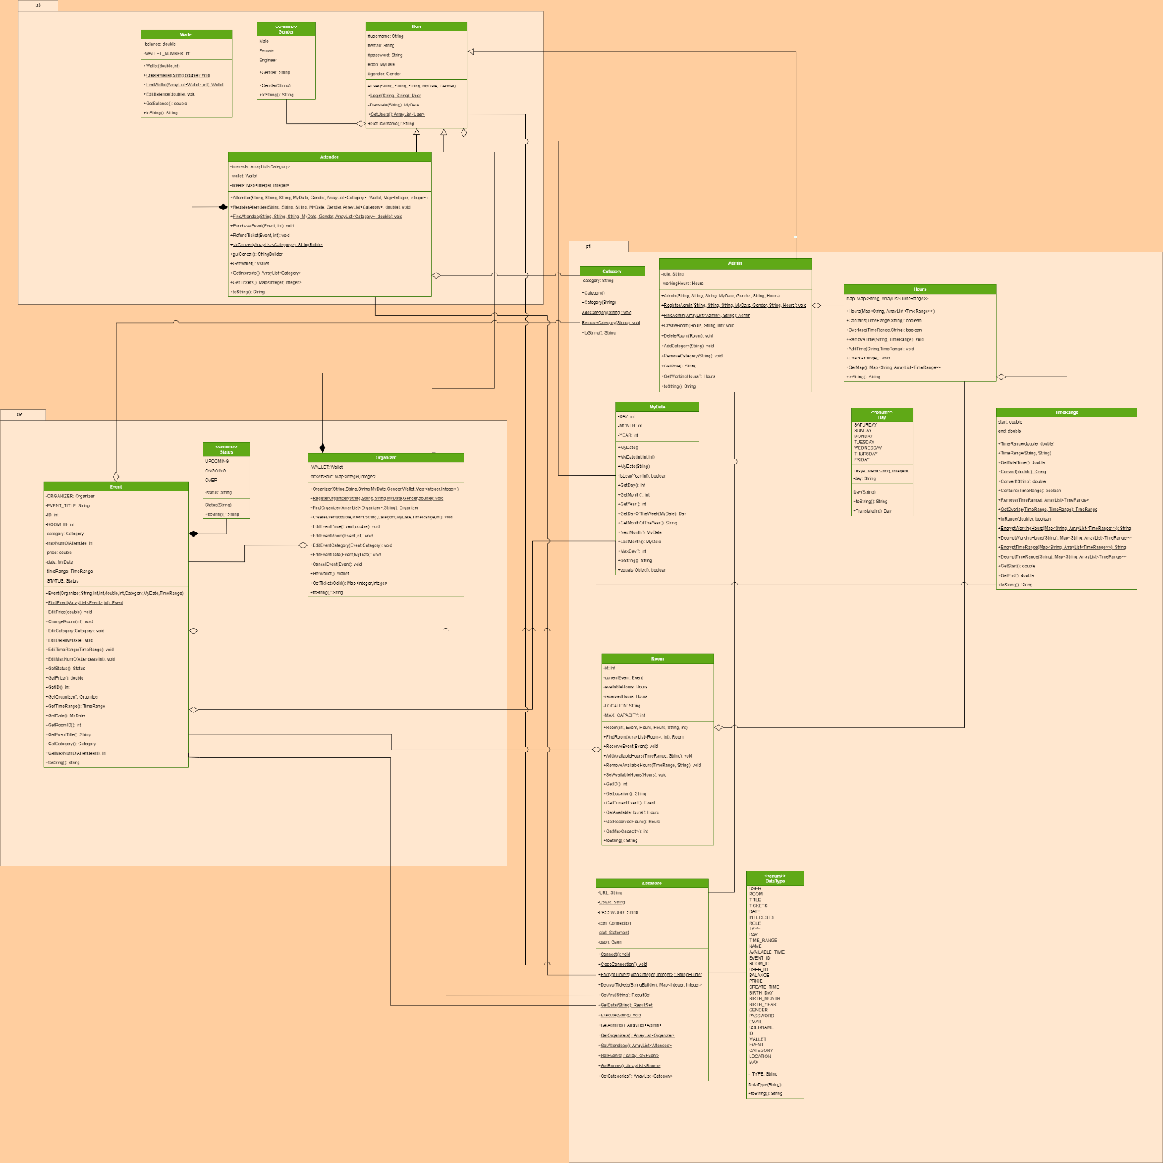

# **Detailed Description**

This application is an Event Management System, made with OOP principles such as encapsulation and inheritance, and designed to store the data of users with different types (Admins, Organizers, Attendees), and store the data of rooms and events and allow for Admins to add rooms, and Organizers to add events, and Attendees to purchase tickets to those events. The System is designed to be safe, scalable and maintainable.

Required Modules: javafx.controls, javafx.fxml, org.controlsfx.controls, com.dlsc.formsfx, com.google.gson, java.sql, java.desktop, jdk.httpserver.

External Dependencies:

From Maven: com.google.code.gson

From JAR: mysqlconnector-j-9.3.0 (provided in the GitHub)

* **Database (abstract)**

### **Data Fields:**

* Private static final String URL: Holds the url of the mysql database.
* Private static final String USER: Holds the user of the mysql database.
* Private static final String PASSWORD: Holds the password of the mysql database.
* Private static Connection con: Holds the connection to the mysql database that is initialized when starting the app.
* Private static Statement stat: Holds the statement for the mysql database to execute commands.
* Private static Gson gson: Initializes Gson which helps in storing json lists in the mysql database.

### **Functions:**

* Public static Connect(): Takes no parameters and returns void, it initializes the connection to the mysql database.
* Public static CloseConnection(): Takes no parameters and returns void, it terminates the connection to the database.
* Public static EncryptTickets(): Takes parameter of type Map<Integer, Integer> and returns StringBuilder, it encrypts the tickets map (from the attendee and organizer) in a specific string format to save it in the database.
* Public static DecryptTickets(): Takes parameter of type StringBuilder and returns Map<Integer, Integer>, reverses the encryption done by EncryptTickets function.
* Public static GetAny(): Takes parameter String as the sql query and returns the ResultSet.
* Public static GetData(): Takes parameter String and returns ResultSet (from mysql), it takes the string and performs a mysql query to get the data needed (this makes use of the DataType enum to prevent any typos in the mysql commands.
* Public static Execute(): Takes parameter String and returns void, the string is mysql command for the database to execute (example: insert, delete, etc…).
* Public static GetAdmins(): Takes no parameters and returns ArrayList<Admin>, it returns an arraylist containing all admins in the database.
* Public static GetOrganizers(): Takes no parameters and returns ArrayList<Organizer>, it returns an arraylist containing all organizers in the database.
* Public static GetAttendees(): Takes no parameters and returns ArrayList<Attendee>, it returns an arraylist containing all attendees in the database.
* Public static GetEvents(): Takes no parameters and returns ArrayList<Event>, it returns an arraylist containing all events in the database.
* Public static GetRooms(): Takes no parameters and returns ArrayList<Room>, it returns an arraylist containing all rooms in the database.
* Public static GetCategories(): Takes no parameters and returns ArrayList<Category>, it returns an arraylist containing all categories in the database.
* **DataType (Enum)**

It contains many different states that correspond to a string, which indicated the type of data you try to insert or get from the mysql database. This class is not mandatory but it helps in minimizing risk of error from making a typo in one of the mysql commands.

### **Data Fields:**

* Private final String _TYPE: Holds the String corresponding to the name of the data type in the database.

### **Functions:**

* Public constructor DataType(): Initializes the _TYPE String.
* Public toString(): Returns the _TYPE String.
* **User (Abstract)**

### **Data Fields:**

* Protected String username: Holds the username to log in with
* Protected String email: Holds the email to log in with
* Protected String password: holds the password to log in with
* Protected MyDate dob: stands for date of birth
* Protected Gender gender: holds gender.
* Protected MyDate dateCreated: holds the date the account was created.

### **Functions:**

* Protected constructor User(): Takes parameters of username, email, password, date of birth, and gender and stores user locally.
* Public static Login(): takes parameters username (or) email, and password and checks against the database if the details are linked to a user and returns the User that has successfully logged in.
* Private Translate(): takes parameter string, which is the string of the time the account was created and returns MyDate instance with the given date.
* Public static GetUsers(): returns all users in an ArrayList<Users>
* Public GetUsername(): returns username in string.
* **Gender (Enum)**

It contains the 2 genders and a third special one (MALE, FEMALE, ENGINEER). It also links each gender string containing the gender in string format, for ease of access.

### **Data Fields:**

* Private final String GENDER: Holds the gender in string format.

### **Functions:**

* Constructor Gender(): This initializes the gender String to the corresponding string format.
* Public toString(): Returns the gender String.
* **Admin (extends User)**

### **Data Fields:**

* Private String role: Holds the role of the admin (example: Manager, Data Engineer).
* Private Hours workingHours: Holds the admin’s working hours in object of class Hours.

### **Functions:**

* Public constructor Admin(): Takes parameters username, email, password, date of birth, gender, role, and working hours. This creates an object of the Admin locally only, but does not save anything in the database.
* Public static RegisterAdmin(): Takes parameters String username, String email, String password, MyDate date of birth, Gender gender, String role, and Hours working hours. Returns void. This inserts a new user of type admin in the mysql database if the entered details are valid.
* Public static FindAdmin(): Takes parameters ArrayList<Admin> and String username and returns Admin, It searches the arraylist for the Admin with the username given.
* Public CreateRoom(): Takes parameters Hours available hours, String location, int capacity. Returns void. This function inserts a new room into the database if the given details are valid.
* Public DeleteRoom(): Takes parameter Room, returns void. This deletes the given room from the database.
* Public AddCategory(): Takes parameter String category name, returns void. This calls the AddCategory() in the Category class.
* Public RemoveCategory(): Takes parameter String category name, returns void. This calls the RemoveCategory() in the Category class.
* Public GetRole(): returns the role data field.
* Public GetWorkingHours(): returns the workingHours data field.
* Public toString(): Returns String. This returns a string containing all the admin’s information.
* **Organizer (extends User)**

### **Data Fields:**

* private final Wallet WALLET: Holds the organizer’s wallet.
* private Map<Integer, Integer> ticketsSold: Holds a map of all tickets sold (the event ID and the number of tickets sold).

### **Functions:**

* public Organizer(): Takes parameter of username, email, password, date of birth, gender, wallet and tickets sold and creates an object of the Organizer locally after checking its validity but does not save anything in the database.
* public static RegisterOrganizer(): Takes parameter of username, email, password, date of birth, gender and balance. This inserts a new user of type Organizer in the mysql database if the entered details are valid.
* public static FindOrganizer(): Takes parameters of an ArrayList of organizers and a username and returns the organizer of the same username.
* public CreateEvent(): Takes parameters of Organizer, Event Title, event ID, maximum number of attendees, event price, Room ID, category, event date and event time range and store the event in the database after checking the information validity.
* public EditEventPrice(): Takes parameter of an event and a price and modifies the event’s price after checking the validation of the data.
* public EditEventRoom(): Takes parameter of an event and a room ID and modifies the event’s room after checking the validation of the data.
* public EditEventCategory(): Takes parameter of an event and a category and modifies the event’s category after checking the validation of the data.
* public EditEventDate(): Takes parameter of an event and a date and modifies the event’s date after checking the validation of the data.
* public CancelEvent(): Takes an event as parameter and removes this event from the database and refund all the tickets bought to the attendees (only if the event’s status is Upcoming).
* public GetWallet(): returns a reference for the wallet.
* public GetTicketsSold(): returns the map of all tickets sold (the event ID and the number of tickets sold).
* Public toString(): returns a formatted string of all the information of the event.
* **Attendee (extends User)**

### **Data Fields:**

* Private ArrayList<Category> Interests: Holds the interests of the attendee (like gaming, ceremonies, weddings, etc)
* Private Map<Integer, Integer> tickets: holds the attendees tickets in a map, with Room ID as the key, and the number of tickets as the value corresponding to the key.

### **Functions:**

* Public constructor Attendee(): Takes parameters username, email, password, date of birth, gender, interests, wallet, and tickets. This creates an object of the Attendee locally only, but does not save anything in the database.
* Public static strConvert(): returns StringBuilder of the users interests in a certain format [“interest1”,”interest2”,”interestN”] , useful for database purposes.
* Public guiConcat(): Formats the category arraylist for gui purposes.
* Public static RegisterAttendee(): Takes parameters String username, String email, String password, MyDate date of birth, Gender gender, ArrayList<Category> interests, Wallet wallet, and Map<Integer, Integer> tickets. Returns void. This inserts a new user of type attendee in the mysql database if the entered details are valid.
* Public static FindAtendee(): Takes parameters ArrayList<Attendee> and String username and returns Attendee, It searches the arraylist for the Attendee with the username given.
* Public PurchaseEvent(): takes parameters of the event of which to buy tickets for, and the wanted number of tickets, if the tickets are available and event is suitable for ticket selling, the tickets are bought and stored in the attendee’s Map of tickets and Wallet is changed accordingly.
* Public RefundEvent(): takes parameters of the event of which to refund tickets from, and the wanted number of tickets, if the tickets are available and event is suitable for ticket refunding, the tickets are refunded and removed from the attendee’s Map of tickets and Wallet is changed accordingly.
* Public GetWallet(): returns attendee’s Wallet wallet.
* Public GetInterests (): returns attendee’s ArrayList<Category> interests.
* Public GetTickets (): returns attendee’s Map<Integer,Integer> tickets.
* Public toString(): Returns String. This returns a string containing all the attendee’s information.
* **Room**

### **Data Fields:**

* Private int id: the room’s id
* Private Event currentEvent: holds the current event held in the room
* Private Hours availableHours: the room’s available hours on a weekly basis (Saturday through Friday)
* Private Hours reservedHours: the room’s reserved hours aka hours an event will take place.
* Private final String LOCATION: room’s location
* Private final int MAX_CAPACITY: room’s maximum capacity

### **Functions:**

* Public constructor Room(): Takes parameters of id, current event, available hours, reserved hours, room location, and maximum capacity and stores room locally.
* Public static FindRoom(): takes parameters of an arraylist of rooms and the room id we are searching for and returns the Room if found, null if not found.
* Public ReserveEvent(): takes the event to reserve as parameter and checks if the room is free and can hold this event (as in if the time is suitable and if the capacity can hold the event) and if all checks are passed, room is reserved for this event.
* Public AddAvailableHours(): takes the day in which we want to add hours and the TimeRange we want to add. If day doesn’t exist, it adds the day along with the hours.
* Public RemoveAvailableHours(): takes parameters the day and timerange we want to remove, if the day and timerange exists, the time is removed, if doesn’t exist, nothing happens to the avaiableHours
* Public SetAvailableHours(): takes Hours as parameter, and sets it as the avaible hours.
* Public GetID(): returns Room ID
* Public GetLocation(): returns the room location.
* Public GetCurrentEvent: returns currentEvent
* Public GetAvailableHours: returns availableHours
* Public GetReservedHours(): returns reservedHours
* Public GetMaxCacapcity(): returns MAX_CAPACITY
* **Event**

### **Data Fields:**

* Private final Organizer ORGANIZER: Holds the organizer of the event.
* Private final String EVENT_TITLE: Holds the title of the event.
* Private final int ID: Holds the ID of the event.
* Private final int ROOM_ID: Holds the room ID of the room in which the event takes place.
* Private Category category: Holds the category of the event.
* private int maxNumOfAttendees: Holds the maximum number of attendees that can join the event.
* Private double price: Holds the price of the event.
* Private MyDate date: Holds the date of the event (example: 14/12/2006).
* Private TimeRange timeRange: Holds the time range of the event (example: 18:00-22:00).
* Private final Status STATUS: Holds the status of the event (example: upcoming, ongoing, over).

### **Functions:**

* Public Event(): Takes parameters Organizer, Event Title, event ID, maximum number of attendees, event price, Room ID, category, event date and event time range. This creates an object of the Event locally but does not save anything in the database.
* public static FindEvent(): Takes parameters of an ArrayList of events and the event ID and returns the event of the same ID.
* Public EditPrice(): takes a parameter of the new price and edits it in the object and database.
* Public ChangeRoom(): takes a parameter of the new room and edits it in the object and database after checking its validity.
* Public EditCategory(): takes a parameter of the new Category and edits it in the object and database after checking its validity.
* Public EditDate(): takes a parameter of the new date and edits it in the object and database after checking its validity.
* Public EditTimeRange(): takes a parameter of the new time range and edits it in the object and database after checking its validity.
* Public EditMaxNumOfAttendees(): takes a parameter of the new number and edits it in the object and database after checking its validity.
* Public GetStatus(): returns the Status of the event.
* Public GetPrice(): returns the ticket price.
* Public GetID(): returns the event ID.
* Public GetOrganizer(): returns the Organizer of the event.
* Public GetTimeRange(): returns the time range of the event.
* Public GetDate(): returns the date of the event.
* Public GetRoomID(): returns the event’s room ID.
* Public GetEventTitle(): returns the event title.
* Public GetCategory(): returns the Category of the event.
* Public GetMaxNumOfAttendees(): returns the maximum number of attendees.
* Public toString(): returns a formatted string of all the information of the event.
* **Status (Enum)**

It contains three states that the event could be, which are the “Upcoming” events, the ”Ongoing” events and the “Over” events. They are used to minimize the chances of logical errors (example: buying a ticket for over events).

* **Category**

### **Data Fields:**

* Private String category: Holds the name of the category in string format.

### **Functions:**

* Public Constructor Category(): This creates an object of Category locally and gives it the “Default” category.
* Public Constructor Category(): Takes parameter String and creates an object of Category locally with this string as the category name if it is a name that exists in the Category database.
* Static AddCategory(): Takes parameter String and returns void. It inserts a new category into the category database, if it doesn’t exist already.
* Static RemoveCategory(): Takes parameter String and returns void. It deletes the given category from the database, if it exists.
* Public toString(): Returns the category String.
* **Wallet**

### **Data Fields:**

* private double balance: Holds the wallet balance.
* private final int WALLET_NUMBER: Holds the wallet number.

### **Functions:**

* Public Wallet(): takes parameters of the balance and wallet number and creates an object of the Wallet locally after checking information validity and does not save anything in the database.
* Public static CreateWallet(): takes parameter of the username and balance and insert the wallet into the database and assign the balance to the username.
* public static FindEvent(): Takes parameters of an ArrayList of Wallets and a wallet number and returns the Wallet of the wallet number.
* Public EditBalance(): takes a parameter of an amount and edits the balance of the wallet (either by increase or decrease) and in case of decreasing the balance, it checks if the amount is valid.
* Public GetBalance(): returns the wallet balance.
* Public toString(): returns a formatted string of all the information of the wallet.
* **TimeRange**

### **Data Fields:**

* Double start: Holds the starting hour of the time range (example: 14:15 -> 14.25).
* Double end: Holds the ending hour of the time range.

### **Functions:**

* Public Constructor TimeRange(): Take two double parameters (the start and end), and creates a local object of the class with the given doubles.
* Public Constructor TimeRange(): Takes two String parameters. It makes use of the Convert() function to convert the string time range to doubles, and creates a local object with those doubles.
* Public GetTotalTime(): Takes no parameters and returns double. It calculates the total time taken by the time range by subtracting the start from the end.
* Public Static Convert(): Takes parameter of type double and returns String. Converts a time from double to String (example: 6.25 -> 06:15).
* Public Static Convert(): Takes parameter of type String and returns double. Converts a time from String to double.
* Public Contains(): Takes parameter TimeRange and returns a boolean. It calculates if the given time range is all inside the time range of the instance object that calls the function.
* Public Remove(): Takes parameter TimeRange and returns an ArrayList<TimeRange>. It removes the given time range from the instance object the calls the function and returns an array list containing the time ranges that remain.
* Public Static GetOverlap(): Takes two parameters TimeRange, and returns a TimeRange. This calculates the overlap between any two time ranges and returns that overlap in another time range. It returns null if there is no overlap.
* Public InRange(): Takes parameter double and returns boolean. It checks if the given double (symbolizing an hour) is inside the time range of the instance object that calls this function.
* Public Static EncryptWorkingHours(): Takes parameter Map<String, ArrayList<TimeRange>> and returns a String. This function encrypts the map (symbolizing available hours or working hours) to a String format that can be stored in the mysql database (Check the comments in the function for example).
* Public Static DecryptWorkingHours(): Takes parameter String and returns Map<String, ArrayList<TimeRange>>. This function reverses the encryption done by the EncryptWorkingHours() function.
* Public Static EncryptTimeRange(): Takes parameter Map<String, ArrayList<TimeRange>> and returns a String. This function encrypts the map (symbolizing reserved hours, which is different from the above functions because it requires any date not days of the week) to a String format that can be stored in the mysql database.
* Public Static DecryptTimeRange(): Takes parameter String and returns Map<String, ArrayList<TimeRange>>. This function reverses the encryption done by the EncryptTimeRange() function.
* Public GetStart(): Returns the start double.
* Public GetEnd(): Returns the end double.
* Public toString(): Returns the time range in String format (example: “08:00-19:30”).
* **Hours**

### **Data Fields:**

* Map<String, ArrayList<TimeRange>> map: a linked hashMap holding a schedule of days as Strings and their TimeRanges.

### **Functions:**

* Public constructer Hours(): takes map as parameter and stores locally
* Public Contains(): takes a day as string and a timerange and checks whether this timerange is contained in the day taken as parameter, returns the result of the check as Boolean value 1 for is contained, 0 if not contained.
* Public Overlaps(): takes string day and a timeRange and checks if there is any overlap, Boolean return, if overlap exists, returns 1, if overlap doesn’t exist, returns 0.
* Public RemoveTime(): takes parameters of the day we want to remove a time from and the TimeRange we want to remove and removes the time from the map.
* Public AddTime(): takes parameters of the day we want to add and the TimeRange to add, and adds it to the map.
* Public CheckArrange(): Checks the map for any formatting issues and fixes the issues (for instance, a duplicate time, overlapping time)
* Public GetMap(): returns the map.
* Public toString(): returns the map.toString()
* **Day (Enum)**

It contains seven different states (SATURDAY -> FRIDAY) that correspond to a day of the week. It also links each day of the week to a string containing the name of the day in string format, for ease of access.

### **Data Fields:**

* Private String day: Holds the name of the day in string format.
* Public static Map<String, Integer> days: Map with the keys being the day’s name, and the values being integers from 0 to 6 corresponding to Saturday to Friday.

### **Functions:**

* Constructor Day(): This initializes the day String to the corresponding string format of the day.
* Public static Translate(): Takes parameter int which is the number of the day from 0 to 6, and returns the Day corresponding to it.
* Public toString(): Returns the day String.
* **MyDate**

### **Data Fields:**

* private final int DAY: Holds the day.
* private final int MONTH: Holds the month.
* private final int YEAR: Holds the year.

### **Functions:**

* public MyDate(): takes takes no parameters and creates an object with the current date.
* public MyDate(): takes parameters day, month and year as integer values and creates an object of the MyDate locally after checking information validity and does not save anything in the database.
* public MyDate(): takes parameters day, month and year as a string and creates an object of the MyDate locally after checking information validity and does not save anything in the database.
* private static IsLeapYear(): takes the year and returns true if it is a leap year. Used in the validations in the constructors.
* public int GetDay(): returns the day.
* public int GetMonth(): returns the month.
* public int GetYear(): returns the year.
* public static GetDayOfTheWeek(): takes parameter of a date and returns the day of the week of this date (example: Sunday, Monday etc).
* public GetMonthOfTheYear(): returns a the month in string format (ex: November).
* Public NextMonth(): returns MyDate with the 1st of the next month.
* Public LastMonth(): returns MyDate with the 1st of the last month.
* Public MaxDate(): returns an integer with the maximum day of the current month.
* public toString(): returns a formatted string of the date.
* public equals(): takes parameter of an object and returns true of it is equal to the date object calling this method.

**Demo**

The user will be greeted with a login page as shown below.

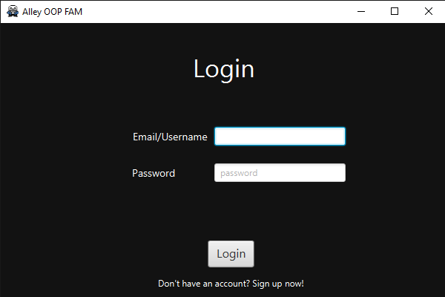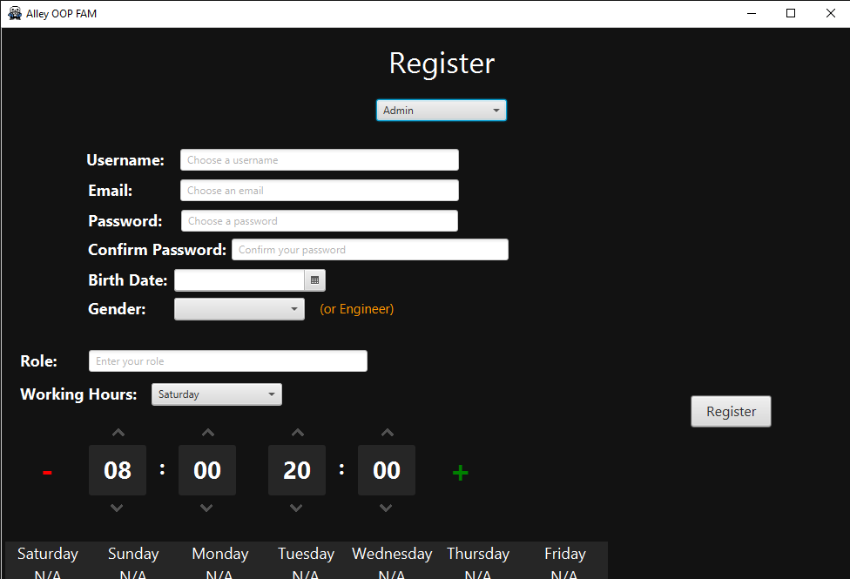The user may choose to login with any existing account, or may press on sign up now, to register a new account.

Case 1: The user logs in as an Admin.

The user will be greeted with the admin main menu, as below.

He will be presented with the following options (Rooms, Categories, Users, Profile). He may also logout.

If he chooses to go to the profile menu, he will be greeted with all details of his account.

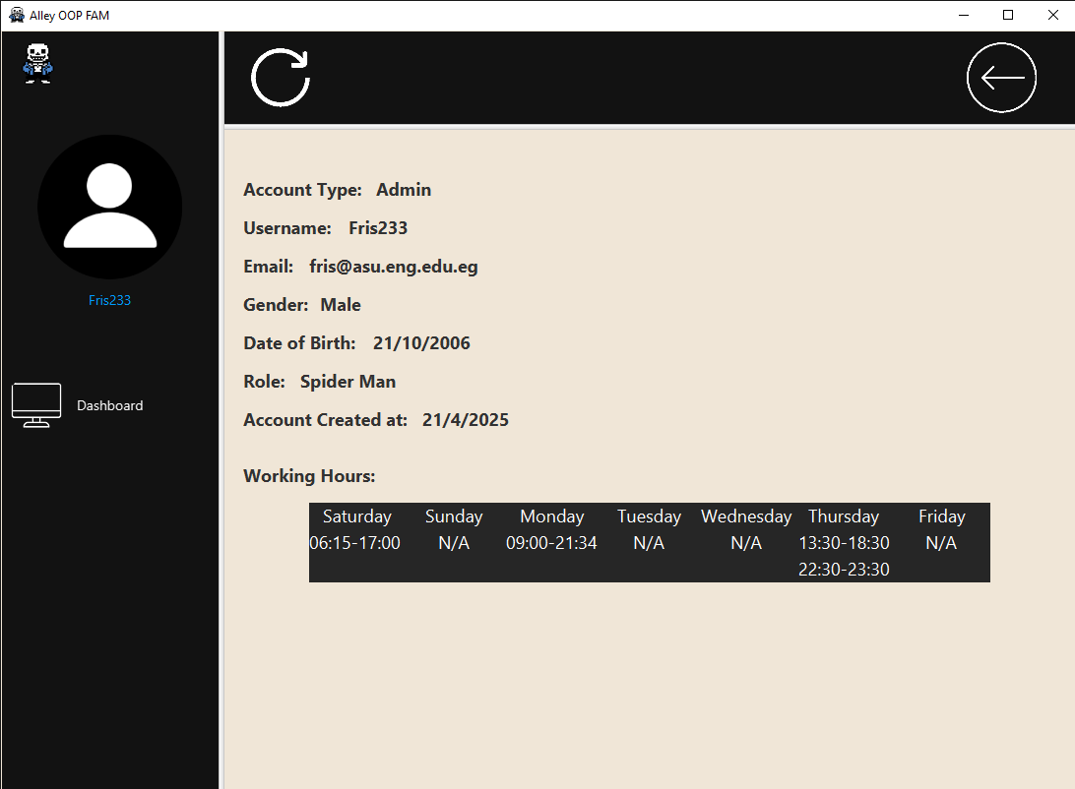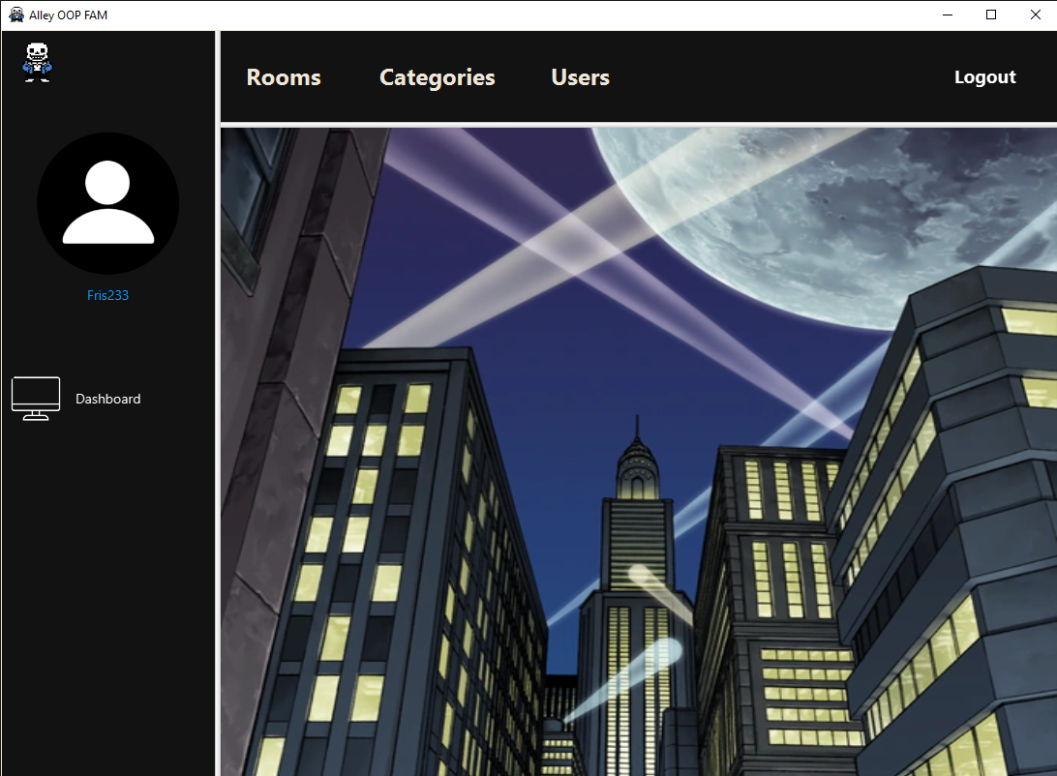

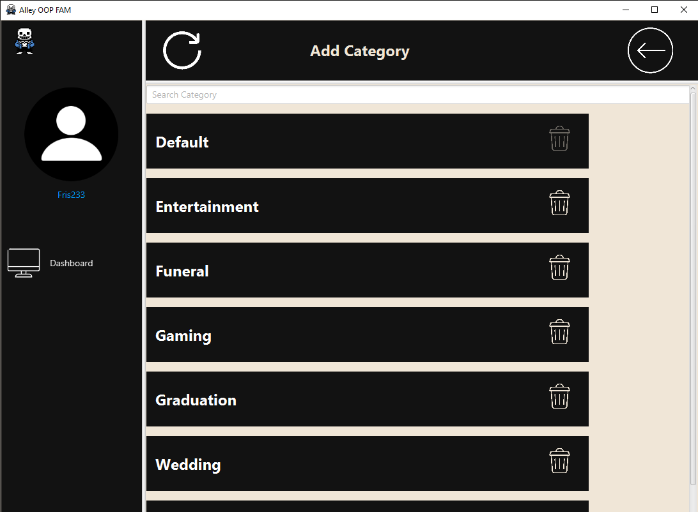If he chooses to go to the Categories menu, he will be able to see all categories in the database. He may also delete any of them aside from the default one. He can also go to the add category menu from here.

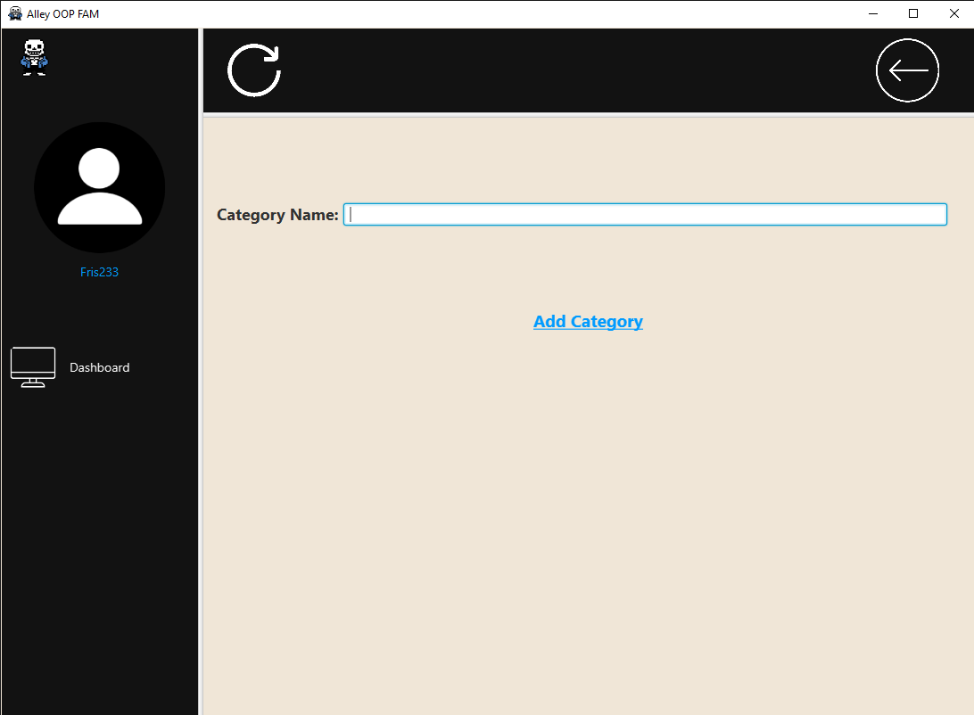If he chooses to go to the add category menu, he can type the category name into the text field to add it

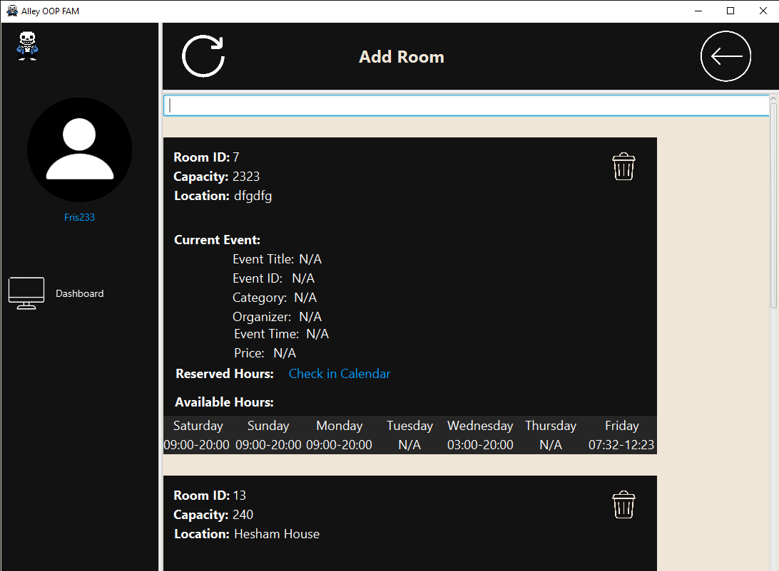Back to the main menu, if he had chosen to go to the rooms menu, he will be able to see all details of all the rooms in the database, as well as any active events at the current time.

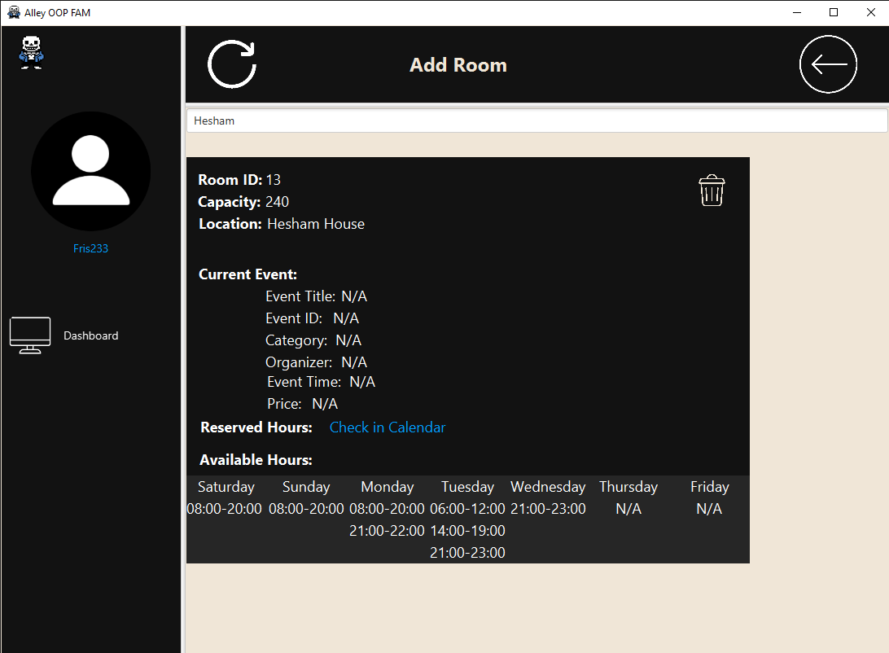The user may also search for the room they would like, which filters by room ID or room Location.

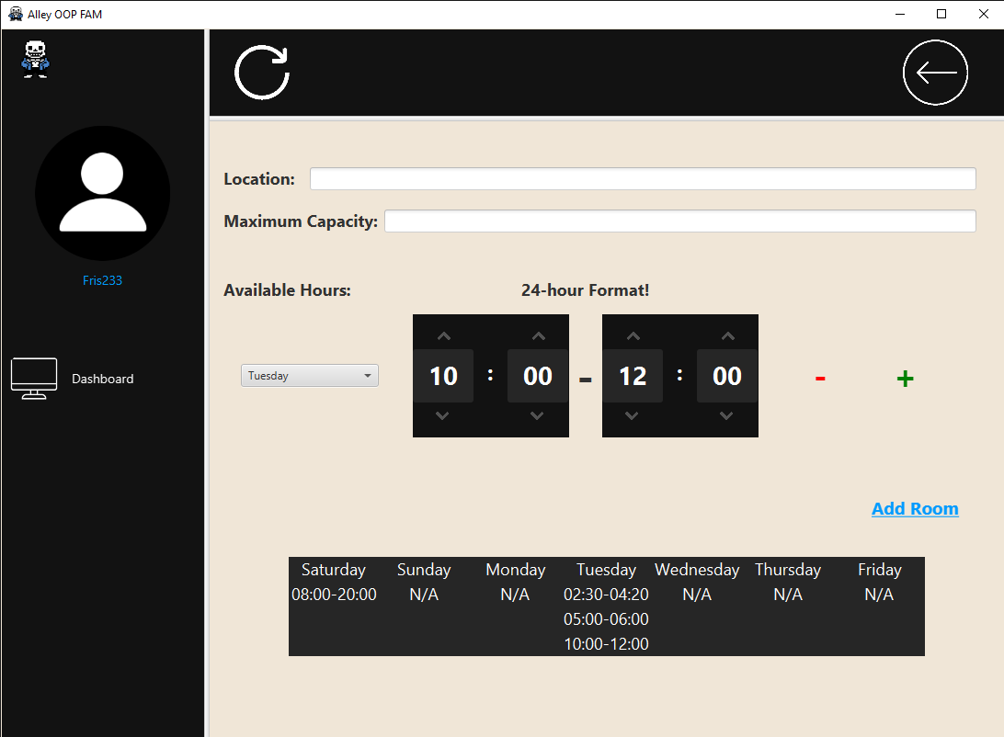Another option in the room menu is adding a new room (Smooth available hours time picker).

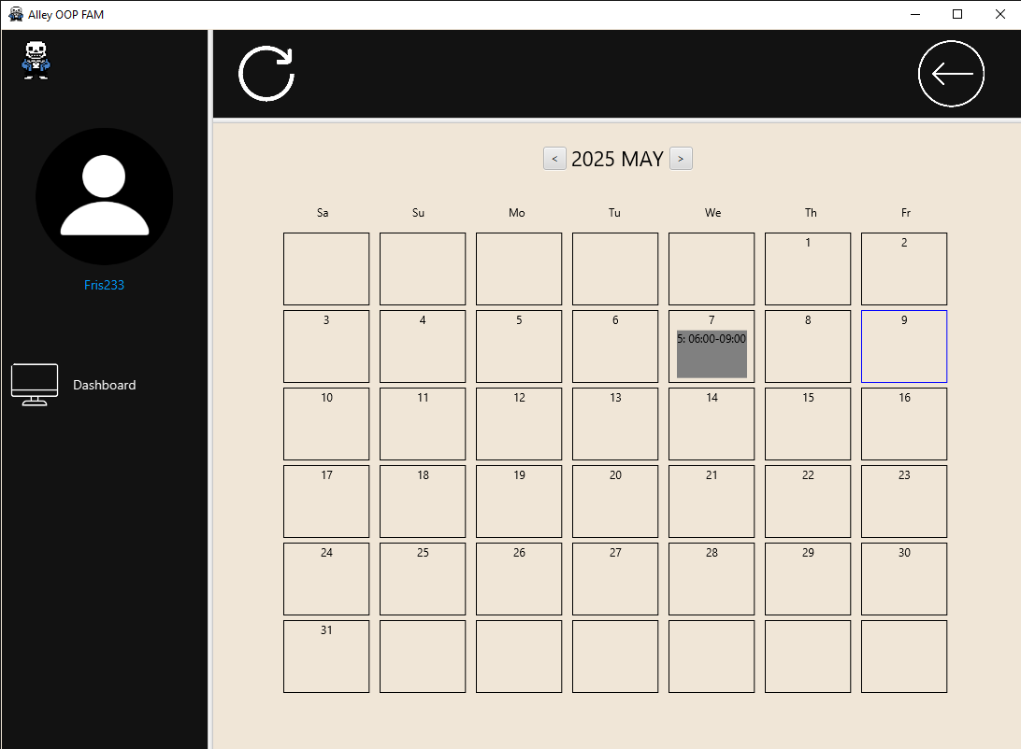Last but not least in the room menu, there is the option of checking the calendar of a specific room, to see all events reserved in that room in the calendar.

Case 2: The user logs in as an Organizer.

* The main menu has 6 buttons, each will take you to a different scene.
* The Logout will get you back to Login scene.
* The profile picture will send you to the profile scene.

The Event Menu:

* This scene shows details of all available events made by the organizer logged in.
* The search bar allows you to search for any event.
* The trash logo allows you to delete an event and refund its price for the attendees who bought this event and removes the money from the organizer.
* You can get back to the main menu using the dashboard button or back button (on top left).
* You can navigate to the create event scene using the Add Event button or from the Create Event button from the main menu.

The Create Event Menu:

* This scene allows the organizer to create a new event.
* The organizer enters all data, and the system creates the event if all information is valid.
* After the organizer enters all data, he presses on Create Event button, if the event is created, the organizer will return to the main menu, else, an error message will appear.
* The user can return to the main menu using the back button or the dashboard button.
* The profile picture navigates the organizer to the profile menu.

The Profile Menu:

* The profile menu shows all information of the organizer (except the password).
* The user can return to the main menu using the dashboard button or the back button.

The wallet Menu:

* The wallet menu shows the wallet number and balance.
* The organizer can deposit or withdraw any amount of money (if valid).
* There is a refresh button to update the balance.
* The organizer can navigate to the main menu using the dashboard button or the back button.

Case 3: The user logs in as an Attendee.

-*Attendee Main Menu*

After logging in as an Attendee, the user is met with this interface with the following buttons on the top:

1. Buy tickets: on mouse click, this sends the user to the Buy Tickets Menu where the user can view and buy tickets for events
2. Profile: this sends the user to their profile screen, showing all relevant information pertaining to the user.
3. My Wallet: this sends the user to view their wallet number and balance, where they can withdraw and deposit (imaginary) money.
4. Events Calendar: The event calendar shows the calendar of all past and future events, with events that align with the user’s interests colour coded to purple.
5. Users: This shows a page of all the users with relevant details and an option to chat with them as previously showcased!
6. Logout: Logs out and sends the user to the login page.

After clicking on the Buy Tickets on the main menu, the user is met with this interface:

1. Event details: Event details are shown of every event in the TicketsPane on the left half, event location, title, id, Room ID, event date, category, organizer, the event time, and event status. (Only upcoming events are showing).
2. Tickets Details: on the top right corner, details pertaining to Tickets. Tickets bought by the user, tickets bought by all users, remaining tickets in stock, and maximum tickets as a whole.
3. Buy/Refund: the bottom right corner feature a Spinner/scrollwheel of numbers, the buy and refund button buy tickets and refund them the number of tickets pulled from the Spinner, with exceptions handled.
4. Searchfield: Where the user can search for any event (granted it is Upcoming) by location, date, title, ID, category.
5. Checkbox: when this checkbox is checked, the Search function only shows events that align with the user’s interests.
6. Remaining buttons: Profile picture on the right sends the user to the Profile menu, Dashboard & Back f

-Attendee *Profile Menu*

After clicking on the Profile on the main menu, this is shown:

1. Attendee Profile details: Attendee details are shown, account type, username and email, gender, date of birth, account date of creation, interests.
2. Wallet Button: This is the exact same as the My Wallet button on the main menu.

*

After clicking on the Wallet button, this is shown:

1. Wallet details: Wallet number and balance.
2. Deposit/Withdraw: After typing in the amount in the text field, we can deposit and withdraw the (imaginary) amounts from our account, with exceptions handled

*

After clicking on the Events Calendar button, this is shown:

* Calendar: A typical calendar is shown with a few additions.
* Current day is outlined by blue
* All events are shown on their day with their event ID and their corresponding event Times.
* Events’ categories that are the same as the user’s interests. These events are coloured in purple.
* Left and right arrows scroll through the months of the year.
* A screenshot of a computer

  AI-generated content may be incorrect.On click of some day/date, it sends the user to the Tickets Menu with the date clicked searched, shown below, which shows all the events on that day.

The Users menu’s demo is here because it is the same for all users.

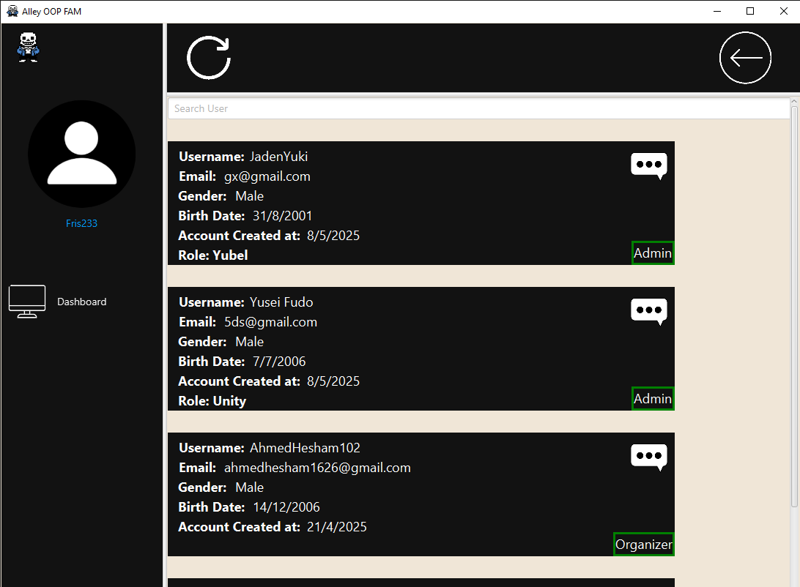If any user chooses the Users menu option, they will be able to see the details for all users in the database as shown below.They may also search for the user they want by username.

Last but not least, in this menu, there is the option to chat with any user, by pressing the chat button next to their username.

The chat feature uses a TCP server bound on a port that is given a public domain using the ngrok process. Other devices may connect to this server and send it messages, it will filter those messages by username, and wait for a Get request with that username to send it, before deleting it from its internal storage.

The server will store the message until it is sent, so if you send a message to a user that isn’t online, and they login and go to their chat with you, it will still send them that message (as long as the server remains active of course).

However, it does not store messages after they are sent, so if a user is in the chat menu and sees a message, after they close the chat, they will not be able to see that message again.

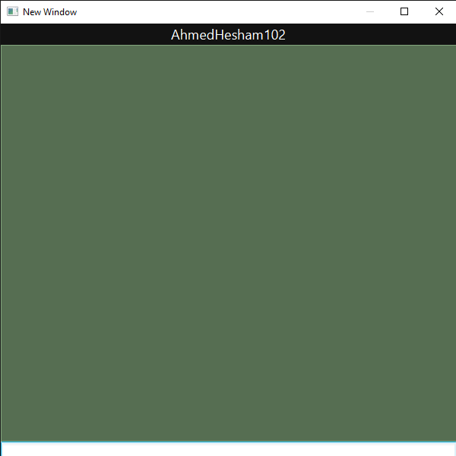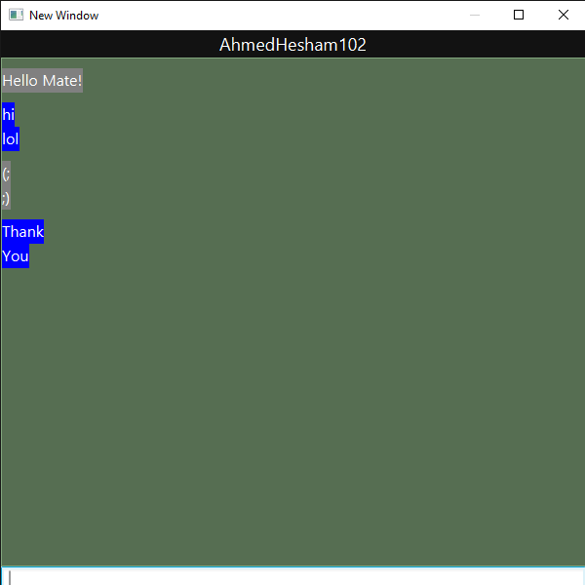

# **GitHub Link**

<https://github.com/ManCityP/OOP_EMS>